**SQL challenge**

**Rohini reddy**

**21wu0101047**

**Team3**

**Q1.)** Query all columns for all American cities in the CITY table with populations larger than 100000.

The CountryCode for America is USA.

SELECT *

FROM CITY

WHERE CountryCode = 'USA' AND Population > 100000;

Output:

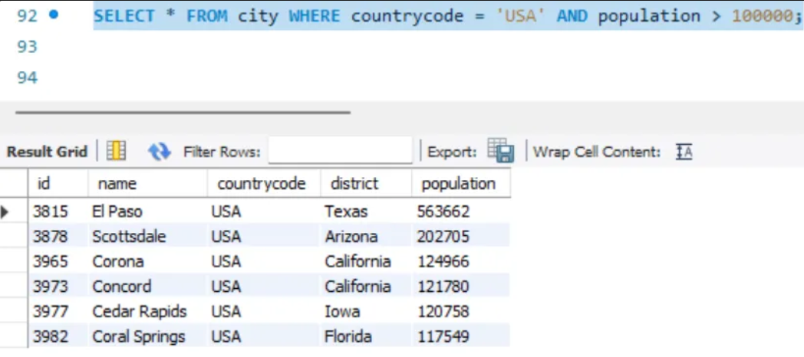

**Q2.)** Query the NAME field for all American cities in the CITY table with populations larger than 120000.

The CountryCode for America is USA.

SELECT NAME

FROM CITY

WHERE CountryCode = 'USA' AND Population > 120000;

Output:

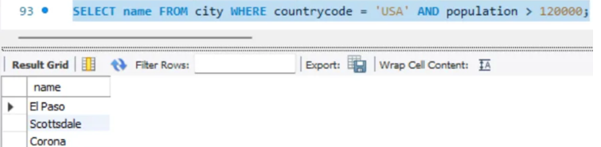

**Q3.)** Query all columns for every row in the CITY table.

SELECT *

FROM CITY;

Output:

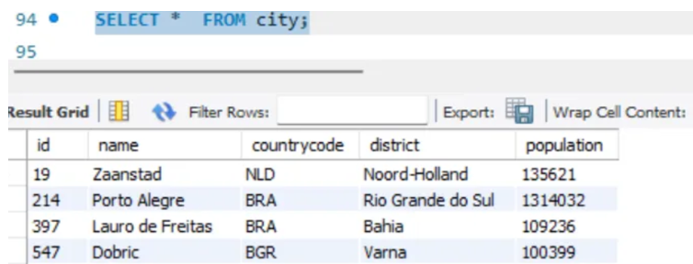

**Q4.)** Query all columns for a city in CITY with the ID 1661.

SELECT *

FROM CITY

WHERE ID = 1661;

Output: 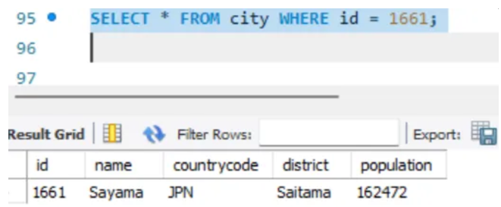

**Q5.)** Query all attributes of every Japanese city in the CITY table.

The CountryCode for Japan is JPN.

SELECT *

FROM CITY

WHERE CountryCode = 'JPN';

Output:

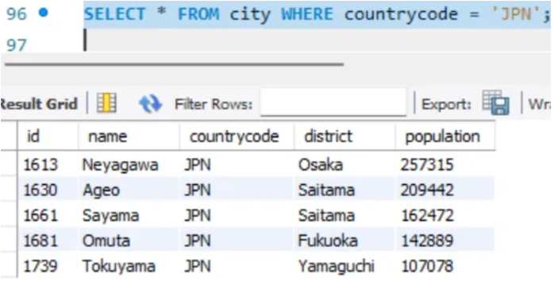

**Q6.)** Query the NAME field of all the Japanese cities in the CITY table.

The CountryCode for Japan is JPN.

SELECT NAME

FROM CITY

WHERE CountryCode = 'JPN';

Output:

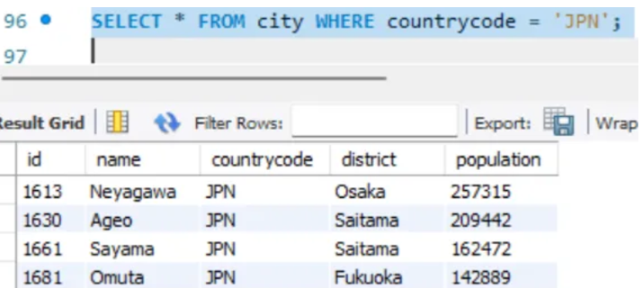

**Q7.)** Query a list of CITY and STATE from the STATION table.

SELECT CITY, STATE

FROM STATION;

Output:

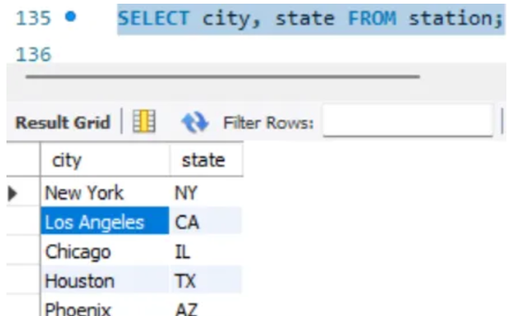

**Q8.)** Query a list of CITY names from STATION for cities that have an even ID number. Print the results in any order, but exclude duplicates from the answer.

SELECT DISTINCT CITY

FROM STATION

WHERE MOD(ID, 2) = 0;

Output:

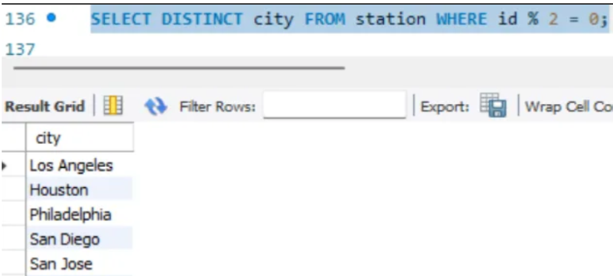

**Q9.)**

SELECT COUNT(CITY) - COUNT(DISTINCT CITY) AS Difference

FROM STATION;

Output:

**Q10.)**

Query for the shortest CITY name:

SELECT CITY, LENGTH(CITY) AS Length

FROM STATION

ORDER BY LENGTH(CITY), CITY

LIMIT 1;

Query for the longest CITY name:

SELECT CITY, LENGTH(CITY) AS Length

FROM STATION

ORDER BY LENGTH(CITY) DESC, CITY

LIMIT 1;

Output:

**Q11.)** Query the list of CITY names starting with vowels (i.e., a, e, i, o, or u) from STATION. Your result cannot contain duplicates

SELECT DISTINCT CITY

FROM STATION

WHERE CITY REGEXP '^[AEIOUaeiou]';

Output:

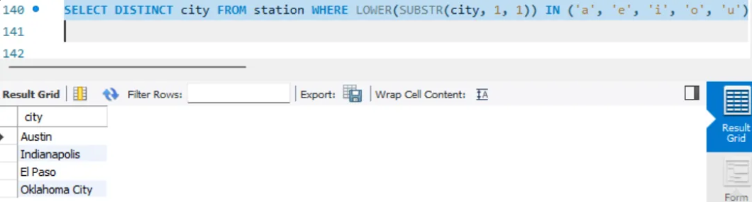

**Q12.)** Query the list of CITY names ending with vowels (a, e, i, o, u) from STATION. Your result cannot contain duplicates.

SELECT DISTINCT CITY

FROM STATION

WHERE CITY REGEXP '[AEIOUaeiou]$';

Output:

**Q13.)** Query the list of CITY names from STATION that do not start with vowels. Your result cannot contain duplicates.

SELECT DISTINCT CITY

FROM STATION

WHERE CITY NOT REGEXP '^[AEIOUaeiou]';

Output:

**Q14.)** Query the list of CITY names from STATION that do not end with vowels. Your result cannot contain duplicates

SELECT DISTINCT CITY

FROM STATION

WHERE CITY NOT REGEXP '[AEIOUaeiou]$';

Output:

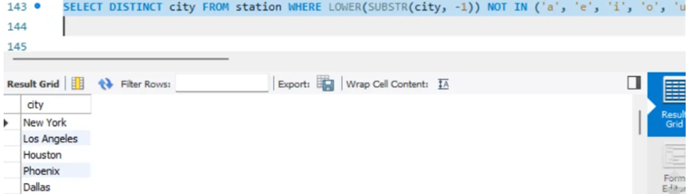

**Q15.)** Query the list of CITY names from STATION that either do not start with vowels or do not end with vowels. Your result cannot contain duplicates.

SELECT DISTINCT CITY

FROM STATION

WHERE CITY NOT REGEXP '^[AEIOUaeiou]'

OR CITY NOT REGEXP '[AEIOUaeiou]$';

Output:

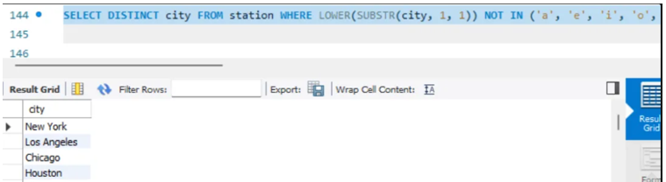

**Q16.)** Query the list of CITY names from STATION that do not start with vowels and do not end with vowels. Your result cannot contain duplicates.

SELECT DISTINCT CITY

FROM STATION

WHERE CITY NOT REGEXP '^[AEIOUaeiou]'

AND CITY NOT REGEXP '[AEIOUaeiou]$';

Output:

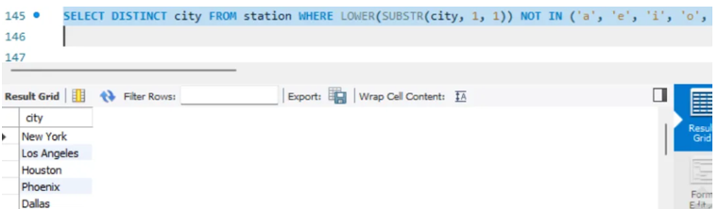

**Q17.)** WITH SalesInQ1 AS (

SELECT DISTINCT product_id

FROM Sales

WHERE sale_date BETWEEN '2019-01-01' AND '2019-03-31'

),

SalesOutsideQ1 AS (

SELECT DISTINCT product_id

FROM Sales

WHERE sale_date NOT BETWEEN '2019-01-01' AND '2019-03-31'

)

SELECT p.product_id, p.product_name

FROM Product p

JOIN SalesInQ1 si ON p.product_id = si.product_id

WHERE p.product_id NOT IN (SELECT product_id FROM SalesOutsideQ1);

Output:

**Q18.)** SELECT DISTINCT author_id AS id

FROM Views

WHERE author_id = viewer_id

ORDER BY id ASC;

Output:

**Q19.)** SELECT

ROUND(

(SUM(CASE WHEN order_date = customer_pref_delivery_date THEN 1 ELSE 0 END) * 100.0) / COUNT(*),

2

) AS immediate_percentage

FROM

Delivery;

Output:

**Q20.)** SELECT

ad_id,

ROUND(

CASE

WHEN SUM(CASE WHEN action IN ('Clicked', 'Viewed') THEN 1 ELSE 0 END) = 0 THEN 0

ELSE (SUM(CASE WHEN action = 'Clicked' THEN 1 ELSE 0 END) * 100.0) /

SUM(CASE WHEN action IN ('Clicked', 'Viewed') THEN 1 ELSE 0 END)

END,

2

) AS ctr

FROM

Ads

WHERE

action IN ('Clicked', 'Viewed') -- Exclude 'Ignored' actions

GROUP BY

ad_id

ORDER BY

ctr DESC,

ad_id ASC;

Output:

**Q21.)** SELECT

e.employee_id,

COUNT(t.employee_id) AS team_size

FROM

Employee e

JOIN

Employee t

ON

e.team_id = t.team_id

GROUP BY

e.employee_id;

Output: The query returns a table with employee_id and their respective team_size.

**Q22.)** SELECT

c.country_name,

CASE

WHEN AVG(w.weather_state) <= 15 THEN 'Cold'

WHEN AVG(w.weather_state) >= 25 THEN 'Hot'

ELSE 'Warm'

END AS weather_type

FROM

Countries c

JOIN

Weather w

ON

c.country_id = w.country_id

WHERE

w.day BETWEEN '2019-11-01' AND '2019-11-30'

GROUP BY

c.country_id, c.country_name;

Output: The query returns a table with country_name and the corresponding weather_type, as shown in the example. Countries without any weather data in November 2019 are excluded from the results.

**Q23.)** SELECT

p.product_id,

ROUND(SUM(p.price * u.units) / SUM(u.units), 2) AS average_price

FROM

Prices p

JOIN

UnitsSold u

ON

p.product_id = u.product_id

AND u.purchase_date BETWEEN p.start_date AND p.end_date

GROUP BY

p.product_id;

Output:

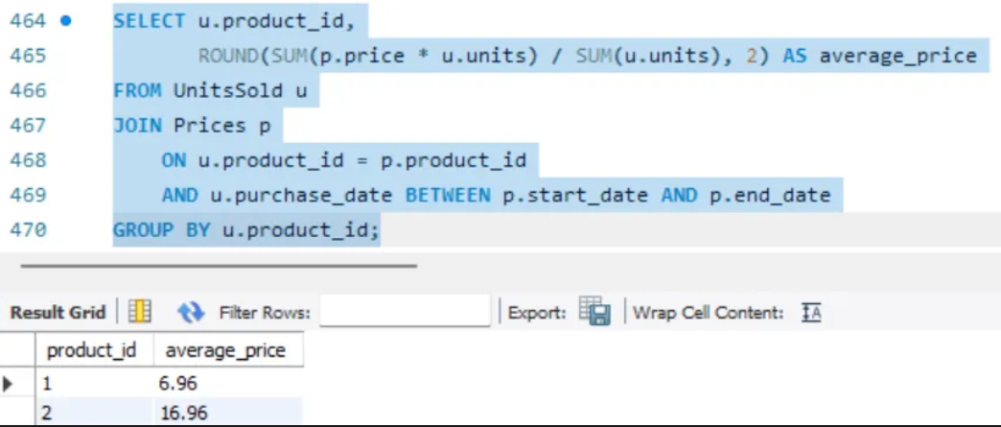

**Q24.)** SELECT

player_id,

MIN(event_date) AS first_login

FROM

Activity

GROUP BY

player_id;

Output:

**Q25.)** SELECT

player_id,

device_id

FROM

Activity

WHERE

(player_id, event_date) IN (

SELECT

player_id,

MIN(event_date) AS first_login

FROM

Activity

GROUP BY

player_id

);

Output: This query will return a table with player_id and the device_id that the player first used to log in, as shown in the example.

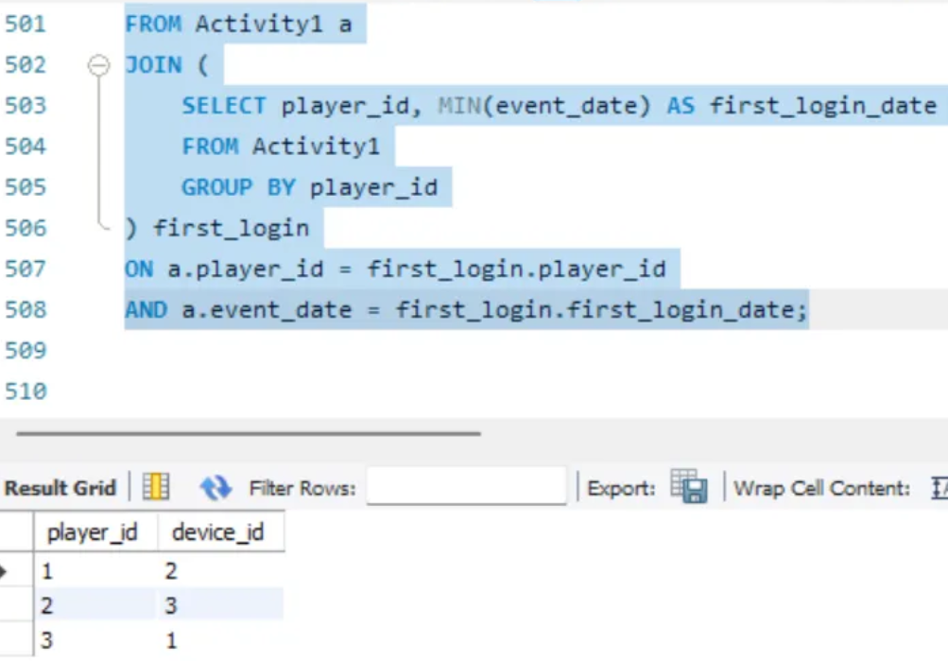

**Q26.)** SELECT p.product_name, SUM(o.unit) AS amount FROM Products p

JOIN Orders o ON p.product_id = o.product_id

WHERE o.order_date BETWEEN '2020-02-01' AND '2020-02-29'

GROUP BY p.product_name

HAVING SUM(o.unit) >= 100;

Output:

